Auburn Public School
Newsletter
Term 3, Week 10 September 2013
Make Good Choices at Auburn Public School
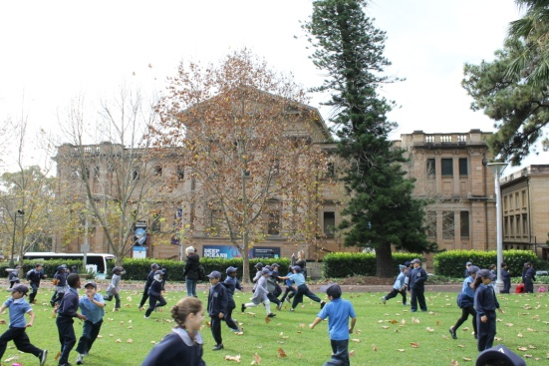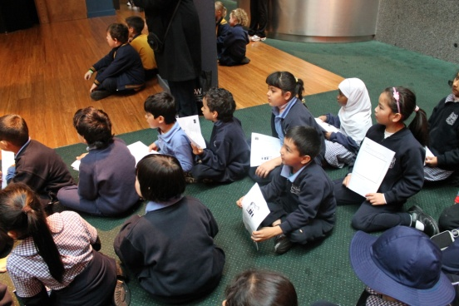
Be Respectful Be Safe Be Active Learners

Principal’s Message

Celebrating Cultural Diversity at Auburn Public School

What a day!

The weather was great and the parents, children and teachers had a wonderful day celebrating the many wonderful cultures we have here at Auburn. Children were treated to a special bag of lollies to celebrate the day!

Parents and teachers enjoyed an amazing lunch consisting of food from so many cultures. It was hard to know what to try! Thank you to the many parents who brought food for the lunch and to our Community Language Teachers who met with many of the local businesses and were able to have food donated to us for the day!

We all enjoyed a fantastic assembly run by our School Captains and then heard some wonderful speakers chat about their culture and of course who could forget all the wonderful dancers.

Finally what about our special “Shake Mate” and ‘We Love Australia” songs – a real celebration of all cultures coming together at this wonderful school.

I would like to take this opportunity to thank all our teachers for their work at getting this special event organised. Everyone worked so hard to ensure the day was a great success.

Thank you to our General Assistants Mr Don Moreton and Mr Cross for always being there to help on days such as this.
To our fantastic Community Language teachers at our school who have been working for weeks, an amazing day! Their hard work really did pay off!

Our dance teachers also a big thank you! I know that you have given up so much of your personal time to teach these children. Your hard work was evident in the quality of the performance.

To the staff at Auburn, thank you for all you did in assisting with the preparation for the day and the work done on the day! Very much appreciated!

To our students, a wonderful effort by all! Great singing, dancing, and behaviour. You are all STARS!

Thank you parents for coming, for your kind donations of food and for helping us celebrate cultural diversity at Auburn.

A special day, one we will remember for a long time! Well done everyone!

Auburn Public School
Beatrice Street, Auburn 2144

Phone: 9646 2200
Fax: 9749 1654

School Email:
auburn-p.admin@det.nsw.edu.au

Principal’s Email:
lisa.markey@det.nsw.edu.au

School Attendance

The Home School Liaison Officer (HSLO) is the person who checks on student attendance. There are many students in our school who are not attending school on a regular basis and their parents will be notified and invited to attend a meeting. Please ensure children attend school every day so they can make the most of their learning opportunities!

School Uniforms

Parents, I am encouraging the wearing of full school uniform by all students. Please co-operate by sending your child in uniform every day. This also includes a school hat. If you have any problems financially with purchasing uniforms, please come and discuss this with me. I am very happy to help families out in this area.

Something Nice!

I have had the pleasure of visiting quite a few classrooms over the past few weeks and I am very impressed with the quality of the work being done. If your child has had a visit from me or they have come to my office with some special work, they will have to share with you some sort of reward from me – a Principal Certificate or Principal stickers. I really enjoy seeing their great work and spending time with our great students!

Swim School

Our swim program will finish at the end of this week so please make sure all payments are completed. A great job organising this event was done by Mrs Tsamoulos and Mrs Boyd with an increase of student numbers participating, the amazing low price was an absolute bargain and thanks go to Mrs Tsamoulos for applying for and recieving a special grant to reduce our costs. Thank you for all your hard work. I know it was appreciated by all !

Student Assistance

If you need assistance with expenses associated with school such as excursions or uniforms, please do not hesitate to come and discuss this issue with either myself or Ms Landon. I do not want any child to miss out on the fun things we do at Auburn.

School Photos

Next Term we will be having our School Photos taken. Order forms will be sent out at the beginning of next term. Photos will be taken on Thursday 7th and Friday 8th November.

Kindergarten 2014

If you have a child who will be 5 by the 31st July, 2014 and you live within our local area, please call into the school to complete enrolment information. Proof of address is required. If you have a neighbour who has a child ready for school, please let them know about enrolling their child for 2014.

Last Day of Term 3 – Friday 20th September

School resumes for students and teachers – Tuesday 8th October, 2013.

I hope everyone has a wonderful and relaxing holiday and I look forward to seeing you all again in Term 4.

Ms Lisa Borg
Principal

General News

K-2 Equipment Areas

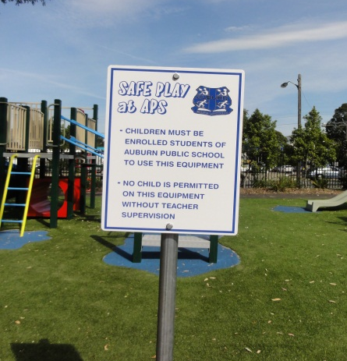

New sign posts have been installed near the K-2 equipment areas. The signs say that “children must be enrolled students of Auburn Public School to use this equipment. No child is allowed on this equipment without teacher supervision”. Parents please don’t allow toddlers to use this equipment.

School Banking

Parents, please ensure student bank books are taken to the office by 9.30am each Friday morning. Please ensure that the desposit slip is signed.

M Uyanik
President P&C

School Spectacular 2013

On the 2nd September 2013 the Dance Group Performed at the School Spectacular. The Dance Group spent the whole day at the Opera House rehearsing and preparing for the evening show. The Dance Group performed to the 80’s song ‘Can’t Touch This’ by MC Hammer and wore baggy hammer pants and colourful jumpers.

The audience roared and cheered as the song started, supporting our students. Three students did a fantastic job in their solos which made the crowd go wild.

A big thank you to the Dance Group for being so well behaved and doing a great job in the school spectacular. You were a hit!!

Miss Isbister and Miss Kisso

Starting School Program

Auburn Public School has been running a Starting School Program for children beginning Kindergarten in 2014. The program aims to help prepare the children for school. The program, run by Miss Ryan is held every Friday morning from 9-11am in the community room.

The children have been learning new songs, listening to stories, learning to work in groups and creating lots of different artworks. Over the coming weeks they will also be making play doh, learning about healthy foods to bring to school and learning dancing.

Currently there are 15 children attending the program along with their mums. It is great to see the children forming friendships and enjoying themselves. It is also great to see all the mums chatting happily while their children learn lots of new things. The program will continue in weeks 1 and 2 of term 4.

Miss Ryan
Organising Teacher
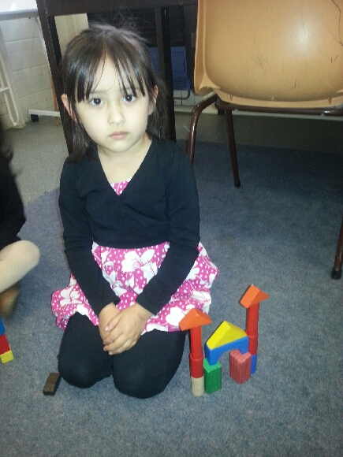

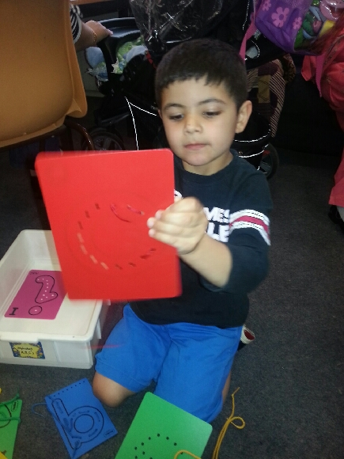

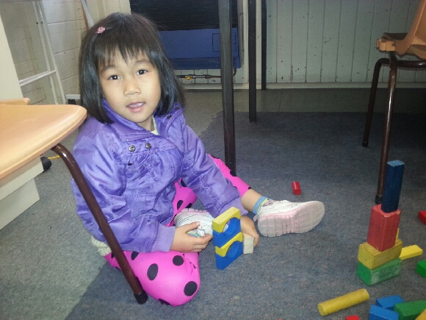

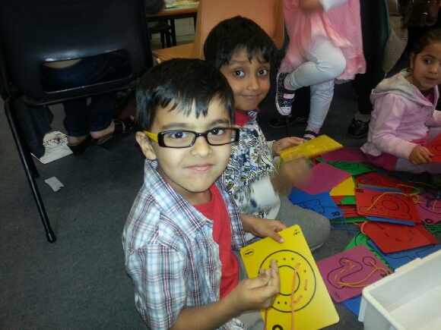

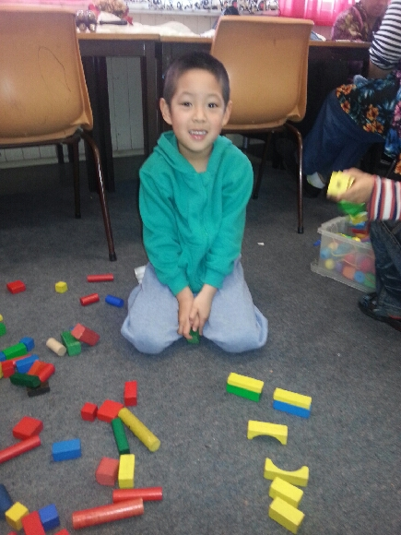
Coming Events

Term 3, 2013
Fri 20th Sept End of Term 3 – Students Last Day

Term 4, 2013
Tues 8th Oct Students Return to school
Thurs 24th Oct P&C (ASPA) Meeting Kindy Hall 9.15am
Tues 29th Oct Kindergarten Farm Excursion
Mon 4th-15th Nov Kindergarten Transition
Thurs 7th Nov School Photos
Fri 8th Nov School Photos
Mon 11th Nov Remembrance Day Ceremony
Wed 18th Dec End of Term 4 – Students Last Day
Thurs 19th Dec Staff Development Day
Fri 20th Dec Staff Development Day

Merit Certificates

Congratulations to the students who were presented with their merit awards at recent assemblies.
Please see class teachers for these awards.

Community Advertising

This newsletter is available as a community service. The advertisements featured are at the request of clients and not necessarily endorsed by Auburn Public School.

