Auburn Public School
Newsletter
Week 2, Term 4 October 2012
Make good choices at Auburn Public School
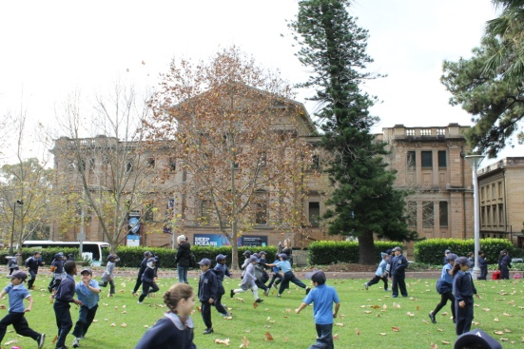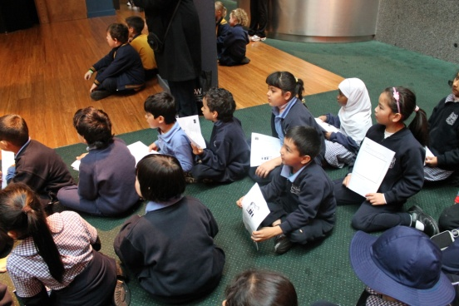
Be Respectful Be Safe Be Active Learners

Principal’s Message

Welcome Back – Term 4

It is great to see everyone back to school and ready to work hard for the last term of 2012. I am pleased to see almost every student in full school uniform including one of our school hats. The children are really taking great pride in wearing their uniform and showing how much they enjoy being part of our school.

I would also like to congratulate our students on their excellent behaviour in the classroom and the playground. The children are really showing just how well they know our school rules. It is a pleasure to walk into classrooms and see our students showing great respect to their teachers and friends and giving their best effort to learn.

In the playground our students are playing well and are being very considerate of each other and their teachers. Our teachers are all so very proud of the effort being made by our students.

I would like to also congratulate our teachers on the terrific job they do every day for the students in their care. At our school, teachers work so hard every day. They are a pleasure to work with! Their hard work and dedication is reflected in student behaviour and their positive attitude to learning. What a great place Auburn Public School is!!

New Deputy Principal for Auburn Public School in 2013

It is with great pleasure that I announce our new Deputy Principal appointed recently after a successful merit selection process is Ms Jodie Landon. Jodie is currently Assistant Principal at Granville Public School and comes with a wealth of knowledge and enthusiasm. I am sure you will all make her welcome and feel part of the Auburn Public School family when she begins working with us in 2013!

School Photos

School Photos will be taken on Wednesday November 7th and Thursday November 8th. The children have all received their order forms which have many different package options and I encourage you to send back your order with enclosed payment as soon as possible. If you would like a family photo of your children who attend our school, special order forms can be obtained from the office.

Auburn Public School
Beatrice Street, Auburn 2144
Phone: 9646 2200
Fax: 9749 1654

School Email:
auburn-p.admin@det.nsw.edu.au

Principal’s Email:
lisa.markey@det.nsw.edu.au

Kindergarten 2013

If you have a child who will be 5 by the 31st July, 2012 and you live within our local area, please call into the school to complete enrolment information. Proof of address is required. If you have a neighbour who has a child ready for school, please let them know about enrolling their child for 2013.

Our Next P & C Meeting

Our next P & C Meeting will be on Thursday 1st November at 9.15 am in the James Waters Hall. Hope to see you all there! Translators will be available!

Ms Lisa Borg
Principal

General News

Mirror Choir Performance

James Waters Hall – Friday 19 October 2012

On Friday 19 October our 3-6 choir will be performing with students from Auburn West, North and Hampden Park Public Schools. This is a follow up of the recent Mirror Choir Performance with the Sydney Children’s Choir that was held at Parramatta Riverside Theatre.

There will be students and teachers from these schools and Auburn that will be watching this repeat performance. All parents are welcome to attend.

Stepping Out

To all Teachers, Parents and Children

We would like to extend a huge thank you to all that took part in our Stepping Out program last term. We thoroughly enjoyed our time at Auburn Public school each Friday and we hope that all participants got as much joy out of it as we did!

It was great to see the enthusiasm on all the children's faces and their eagerness to learn more each week. Thanks to all parents and family that came to support their children at the End-Of-Term Extravaganza.

All that support created a vibrant atmosphere for the performers and it was great to see you all joining in for a couple of dances at the end.

Finally a big thank you to all the teachers for your ongoing support during the sessions and especially Miss Georgiadis for her fantastic organisation of everything Stepping Out related, we couldn't have done it without you!

Thanks again
Ezra and Dean - Stepping Out
Multi Sport Day 2012

Last week students from classes 1/4B, 1/3G, 3/6M, 3/6K, 3/4C, 6B and 5/6P participated in a multi sport day event at Olympic Park.

The students enjoyed participating in various activities such as AFL, soccer, boccia bowls, cricket, softball and golf.

The students were able to meet some Australian Paralympians who have recently won medals at the 2012 Paralympics.

The students also got an opportunity to look at the different sports stalls in the “Return to Sport” Expo being run by the Royal Rehab.

It was a very enjoyable experience for all the participating students and teachers.

Mrs Chaudhry
1/4B Teacher

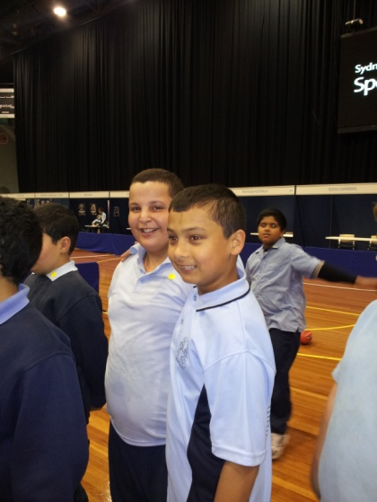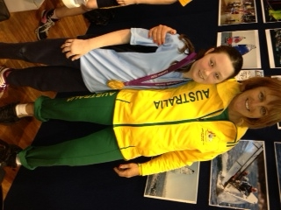

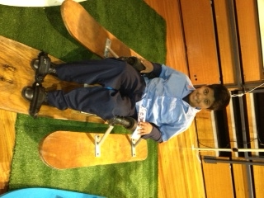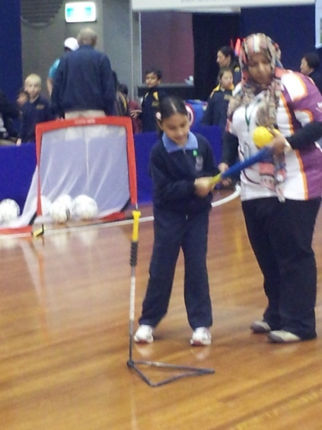

Sensory Playground

We would like to thank all students, parents, family and teachers who have sold or bought tickets to help raise funds for our Sensory Playground. Please continue to bring in any money raised and tickets sold. The raffle will be drawn on Friday, 2nd November, 2012 on the 3-6 site, at morning assembly (9am).

Your support is much appreciated

Miss Bonus

Information for school communities about Measles

Sydney is currently experiencing an outbreak of measles which began in April 2012 and is centred in the South Western Sydney and Western Sydney regions. Many of the cases have been high school students, with a smaller number in primary school. There is potential for the measles outbreak to spread further given young people have large social networks both within and outside of school.

NSW Health advises that measles is a serious viral illness that mainly affects unvaccinated children, teenagers, young adults, and babies too young to be vaccinated. Measles is highly infectious and can easily spread through the air.

Immunisation is effective in preventing the disease. In Australia, infants and young children are vaccinated with measles-mumps-rubella vaccine at 12 months and 4 years of age. People who are at risk of measles include:

- Infants <12 months who are too young to have been routinely vaccinated
- Older children who have not received 2 doses of measles-containing vaccine
- Adults born during or after 1966 who have not received 2 doses of measles- containing vaccine and haven’t had measles infection in the past.

Immunising older siblings and non-immune adults will help prevent the spread of infection to infants who are too young to be vaccinated and who are at risk of severe disease.

The first sign of measles is a high fever which usually begins about 10 to 12 days after exposure to a person with measles (range 7-18 days). A runny nose, cough, red and watery eyes (conjunctivitis), and small white spots inside the cheeks can develop in the initial stage. The rash appears around 14 days after exposure, usually starting on the face and upper neck and spreading over the body, hands and feet. The rash lasts for 4-7 days.

IMPORTANT INFORMATION:
People with measles are usually infectious from just before the symptoms begin until four days after the rash appears. If you have had contact with someone who has had measles and develop a fever, runny nose, cough, red and watery eyes, it may be measles and seek medical advice.

If you suspect measles, see your doctor, clinic or hospital. It is important to ring before your consultation so you can be seen as soon as possible and arrangements can be made to avoid contact with other patients in the waiting room who may be susceptible to measles.

A person with measles should remain at home until four days after the rash appears to reduce the possibility of spreading it to other people.

Further information about measles can be found on the NSW Ministry of Health website at:

http://www.health.nsw.gov.au/factsheets/infectious/measles.html

Term 4, 2012
Fri 19th Oct Beginning School Well
Wed 24th Oct Granville Spectacular Rehearsal
Tues 30th Oct Granville Spectacular Performance –
Opera House
Thurs 1st Nov ASPA Meeting
Wed 7th Nov School Photos
Thurs 8th Nov School Photos
Fri 9th Nov Remembrance Day Ceremony
Week 6 Kindergarten Transition
Thurs 15th Nov Dance Sport Competition
Thurs 15th Nov Music and Games Night
Wed 21st Nov Year 6 Fete
Thurs 22nd Nov ASPA Meeting
Mon 26th Nov Prefect Speeches
Fri 30th Nov Reports Sent Home
Wed 5th Dec High School Orientation
Fri 7th Dec Kindergarten Graduation
Mon 10th Dec K-2 Funarama Visit
Tues 11th Dec K-2 Funarama Visit
Wed 12th Dec 3-6 Presentation
Thurs 13th Dec K-2 Presentation
Thurs 13th Dec Year 6 Farewell
Fri 14th Dec Stage 3 AMF Bowling & Laser Tag
Mon 17th Dec Have a Go Show
Tues 18th Dec Stage 2 Bowling & Movie
Wed 19th Dec Last Day for Students
Thurs 20th Dec School Development Day
Fri 21st Dec School Development Day

Merit Certificates

Congratulations to the following students who were presented with their merit awards at recent assemblies.

Class Certificate of Merit PBIS

KL Ibrahim Goolizadeh Mikail Payir
KM Mansour Dofash Mohammad Al-Masri
KS Mahad Ali Jackson Lin
KT Erfan Akbari Amir Khademi
1K Emre Selvi Maryam Sakhidad
1M Sadaf Yari Ilhan Ersan
1R Simon Ngo Khalid Alasaadi
1/2A Rashid Taimori Grace Lau
1/2D Arpad Kelemen Allaa Al Hussein
1/2S Unzila Khan
2J Shafie Hassan Yoonis Ali
2T Kaan Arslan Connor Lin
2W Sarvin Emami-Naghadeh Vilikesa Bera

Community Advertising

This newsletter is available as a community service. The advertisements featured are at the request of clients and not necessarily endorsed by Auburn Public School.

